THE ART OF DESIGN
IEEE MVSR SB Women in Engineering Affinity Group (WIE) in association with IEEE MVSR CS in collaboration with IEEE Young Professionals Education Society conducted “THE ART OF DESIGN” A Hands-On UI UX Workshop on the 9th of December 2023. The main aim of the workshop was to introduce the participants on the basics of UI/UX and create simple designs using Figma and Adobe XD.
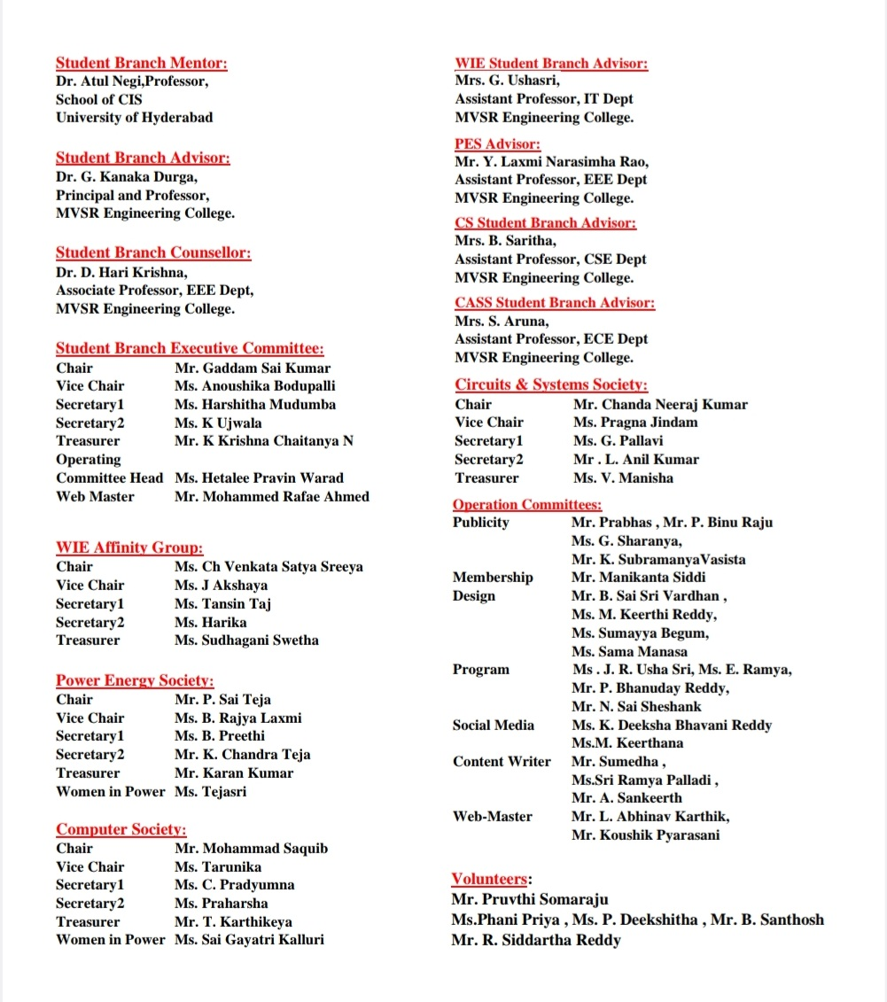
Session Details:
Date: 9th December, 2023
Timings: 10:00 am - 4:30 pm
No. of Attendees: 62
IEEE members: 9; Non-IEEE members: 53
Speaker Details: Ms. Surabhi Seetha, Data Associate at Amazon., and Design Team member, IEEE Young Professionals EDSOC

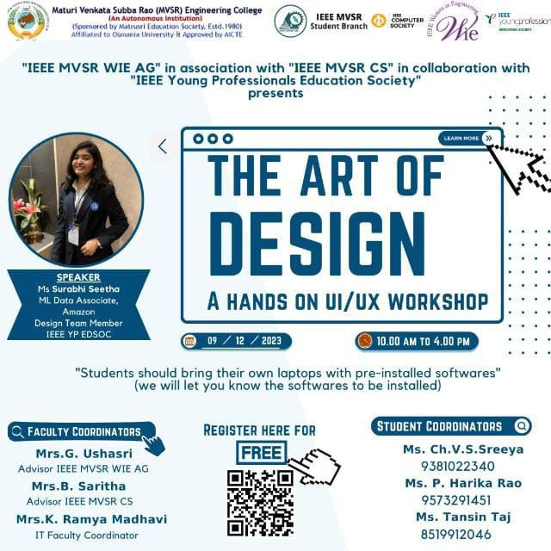Poster of the event

The session commenced with Ms. Harika, Secretary, IEEE MVSR SB WIE Affinity Group, extending a warm welcome to the speaker, Ms. Surabhi Seetha, Data Associate at Amazon., and Design Team member, IEEE Young Professionals EDSOC, Dr. D. Hari Krishna, the IEEE Student Branch Counsellor, Mrs. G. Ushasri, Advisor IEEE MVSR WIE AG, Mrs. B. Saritha, Advisor IEEE MVSR CS, Mrs. K. Ramya Madhavi, IT Faculty Coordinator, the student coordinators, and all the participants.

Subsequently, Dr. D. Hari Krishna, addressed the gathering, sharing insights on the importance of attending workshops and the benefits of IEEE membership. Following that, Mrs. G. Ushasri spoke to the participants about the various benefits and importance of being a member of the WIE Affinity Group. Further, Mrs. B. Saritha spoke to the participants on the various benefits and importance of being a member of CS and then smoothly transitioned to hand over the session to the speaker for the commencement of the workshop.

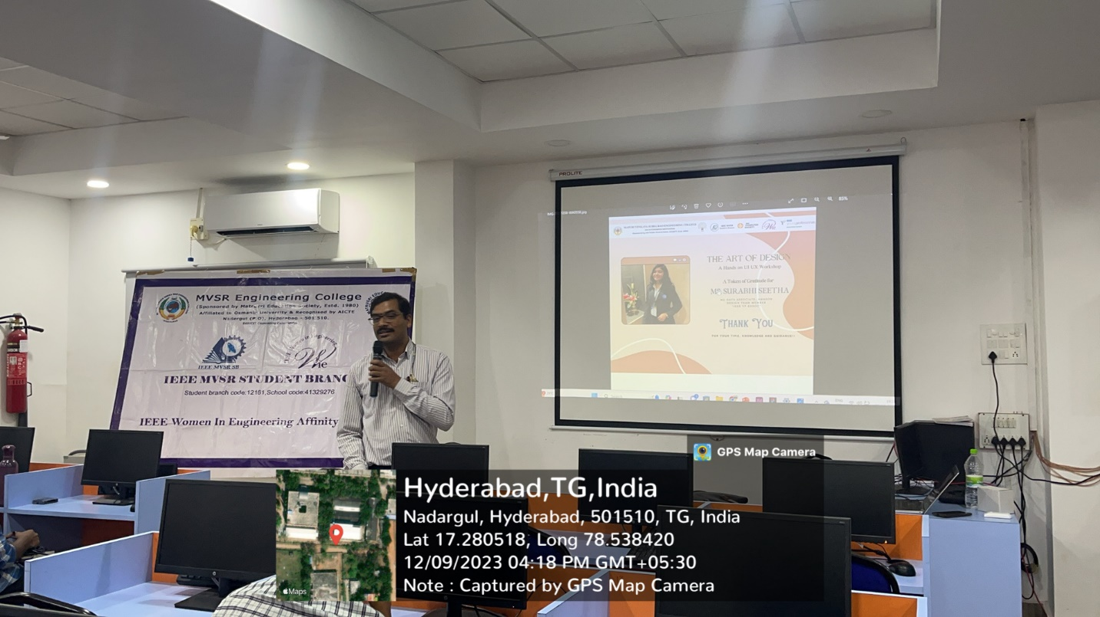
Dr. D. Hari Krishna addressing the gathering
In the morning session of the workshop, Ms. Surabhi Seetha, our esteemed speaker, provided a comprehensive introduction to UI and UX. She delved into the origins and the basics of Ul and UX, drawing parallels to real-world examples and case studies from industry giants like Zomato and Swiggy. The speaker delved into the workings of a designer's mind, emphasizing the crucial collaboration between designers and developers. Ms. Surabhi took the participants through the various stages of designing from wireframing to high-fidelity design with the session being to be both insightful and engaging.

The afternoon session commenced with hands-on experiences in Figma and Adobe XD, enabling participants to unleash their creative instincts. The interactive session facilitated a deeper understanding of the design process as the speaker showcased examples from her designs, explaining the key principles that contribute to effective design.

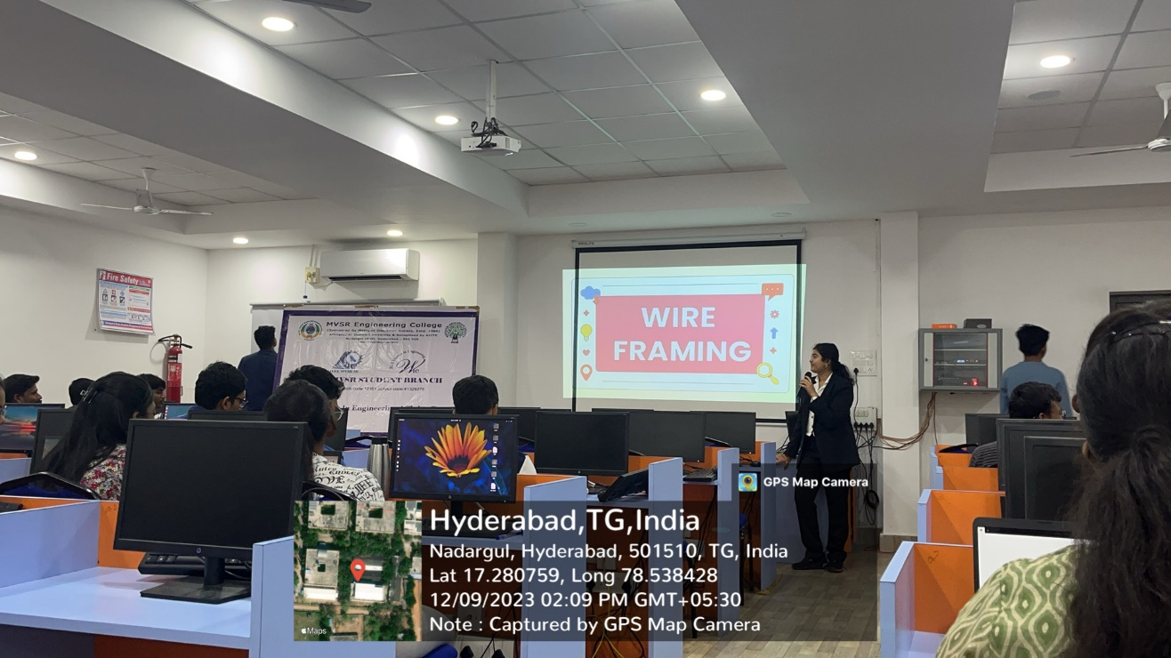

Ms. Surabhi Seetha explaining wireframing
Following this, participants were tasked with creating their wireframe designs. Subsequently, they worked on either Figma or Adobe XD to develop their low-fidelity designs. The assignment entailed the creation of five pages for an OTT platform, encompassing both the login and home pages.

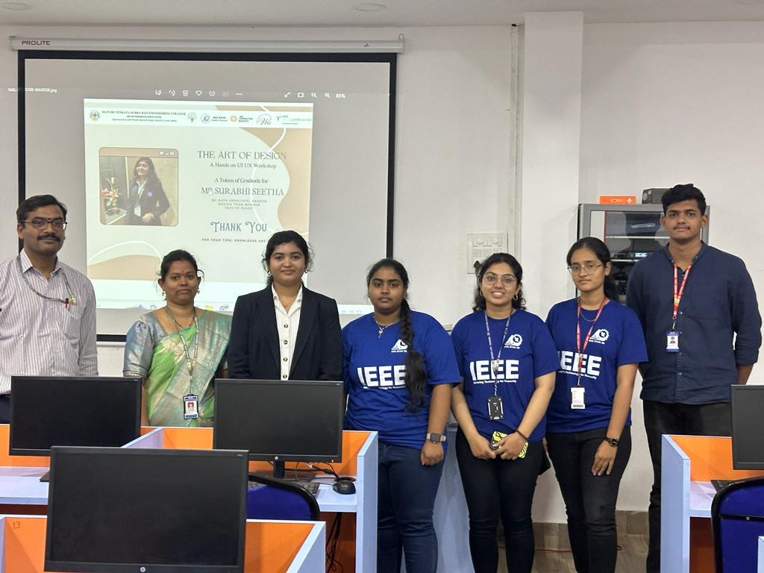
Ms. Surabhi Seetha along with the coordinators
The workshop was concluded by Mrs. G. Ushasri who thanked Ms. Surabhi Seetha for sparing her valuable time conducting such an informative workshop about UI/UX Design and for giving the participants a base to work on and hone their skills for their career. Then, Dr. D. Hari Krishna, the IEEE Student Branch Counsellor and Ms. Ch Venkata Satya Sreeya, Chairperson, IEEE MVSR SB WIE Affinity Group presented the speaker, Ms. Surabhi Seetha with a memento to show gratitude. Thereafter, Ms. Akshaya, Vice-Chair, IEEE MVSR SB WIE Affinity Group gave the vote of thanks followed by Ms. Ch Venkata Satya Sreeya who officially ended the workshop and thanked everyone at the venue for attending the event and for their active participation.

List of Attendees:

S. No | Name | Roll Number | IEEE ID
1 | Dr. D. Harikrishna | Faculty | 90436180
2 | Mrs. B. Saritha | Faculty | 95070854
3 | Mrs. K. Ramya Madhavi | Faculty | NA
4 | Mrs. G Ushasri | Faculty | 98612138
5 | Ch Venkata Satya Sreeya | 2451-20-737-151 | 97488096
6 | J. Akshaya | 2451-20-735-064 | 99216652
7 | Tansin Taj | 2451-21-733-059 | 99228530
8 | P. Harika | 2451-21-737-194 | 99229064
10 | Bhupathi Reddy Budupu | 2451-21-737-132 | 99432768
11 | N. Praharsha | 2451-20-737-170 | 99216068
12 | Karantothu Priyadarshini | 2451-22-733-138 | NA
13 | Jahnavi Kurmapu | 2451-22-733-079 | NA
14 | Karampuri Anusha | 2451-22-733-142 | NA
15 | Somishetti. Lakshmi Prasanna | 2451-21-733-017 | NA
16 | Pendam Aarya Yadav | 2451-22-734-041 | NA
17 | Polsani Sai Ram Rao | 2451-22-733-105 | NA
18 | Mallareddy shiva prasad | 2451-21-734-338 | NA
19 | Ammati Jahnavi | 2451-22-733-111 | NA
20 | Thallapallylakshith | 2451-21-737-312 | NA
21 | Jampala Swathvik | 2451-22-733-076 | NA
22 | Bathini Sai Vikranth Reddy | 2451-22-733-031 | NA
23 | Soyam Praveen prakash | 2451-21-737-182 | NA
24 | Asini Manisha | 2451-21-733-018 | NA
25 | Deekshitha Pilli | 2451-22-733-086 | NA
26 | K Sai Krishna Surya Prakash | 2451-21-737-187 | NA
27 | Mandadi Rohit Reddy | 2451-20-733-159 | NA
28 | Badavath Tharun | 2451-22-735-307 | NA
29 | Jammalamadaka Shiva Shreya | 2451-22-750-009 | NA
30 | Jevala sreeja | 2451-22-733-103 | NA
31 | Vemula Medha | 2451-22-733-132 | NA
32 | Onteddu Pooja | 2451-22-750-008 | NA
33 | Mohammad Abdul Waheed | 2451-22-733-078 | NA
34 | Abhinav Anil Mangala | 2451-22-733-169 | NA
35 | Palugulla Naina | 2451-22-733-186 | NA
36 | Priyanshu Kakularam | 2451-22-749-058 | NA
37 | Chinthakuntla Nandeeshwar Reddy | 2451-21-734-343 | NA
38 | Bhukya sruthi | 2451-21-735-092 | NA
39 | Velimeneti Preethi Reddy | 2451-22-733-098 | NA
40 | Alladi Vishnu sai | 2451-22-733-044 | NA
41 | Maliga Varshitha | 2451-23-733-204 | NA
42 | Kanugu Rajesh | 2451-22-733-172 | NA
43 | Mohammad Shoaib Alam | 2451-22-748-020 | NA
44 | Sai Keerthana Chervirala | 2451-22-733-116 | NA
45 | Kancherla Venkat Sai | 2451-21-733-088 | NA
46 | Saireddy Manasvi | 2451-22-733-061 | NA
47 | Harshita Bompalli | 2451-22-733-021 | NA
48 | Kondapuram akhila | 2451-22-733-017 | NA
49 | Jenige Mythili | 2451-22-733-005 | NA
50 | Rithika Anamoni | 2451-22-733-008 | NA
51 | A Ruchi | 2451-22-733-037 | NA
52 | Gangidi Vineesha Reddy | 2451-22-750-010 | NA
53 | Chikka Dinesh | 2451-21-737-154 | NA
54 | Kommollu Sulochana preethi | 2451-22-733-137 | NA
55 | Ananthula Ujwal | 2451-22-749-004 | NA
56 | K Sai Rohit | 2451-22-733-108 | NA
57 | Sameer Shukla | 2451-22-733-108 | NA
58 | C. Yashwanth Sagar | 2451-21-734-341 | NA
59 | Gopanaboyina Sathvik | 2451-22-735-306 | NA
60 | Arrabothu Jhansi | 2451-21-737-184 | NA
61 | Godeshi Rishitha | 2451-22-733-075 | NA
62 | Allaboina Sathya Pranav | 2451-22-733-124 | NA

Reported by:
IEEE MVSR SB

